Отдел за безопасност на движението
3M, Сграда235-3A-09
Ст. Пол, Минесота 55133-3225 www.3M.oom/mvss
3M™ СИСТЕМА ЗА ЗАРЕЖДАНЕ НА ДАННИ В КАМЕРА СЪС СРЕДНА СКОРОСТ РЪКОВОДСТВО НА ПОТРЕБИТЕЛЯ ИЗДАНИЕ 2.0
СПИСЪК С ИЗВЪРШЕНИТЕ ПОПРАВКИ
ИЗДАНИЕ | ДАТА | КРАТКИ ДАННИ ЗА ИЗВЪРШЕНАТА ПРОМЯНА
1 | 16/07/2009 | Първоначална версия
1.1 | 08/09/2009 | Актуализиране с цел отразяване на комбинираните SM и ERCU възможности за актуализация, както и промяна на името на SpeedSpike Data Loader (SSDL).
2.0 | 10/07/2013 | Актуализиране на 3М номенклатурата за продукти

Настоящият документ представлява последното издание, показано в таблицата по-горе.
Автор: Куифенг Хуанг

The Data Loader works with either deployment type. It can load or update the ERCU key store if running on a machine which has ERCU installed. If running on a machine with SM installed, it will be responsible for loading data from any of the 3 CD’s required by the Session Manager:
3M™ Системата за зареждане на данни на камера със средна скорост (DL, позната преди като SpeedSpike Data Loader, SSDL) предоставя лесен за употреба единичен вход за зареждане на CD или за системата за управление на сесиите (SM) и/или за устройството за възстановяване на доказателства и контрол (ERCU), показани на фиг. 1. Обикновено и SM, и ERCU работят на един компютър, но технически е възможно да работят на отделни компютри. Системата за зареждане на данни работи и с двата типа приложения.
- SM key store CD from the Key Manager (KM )
- Enforcement data CD from the Enforcement Manager (EM)
- Camera shared secrets CD from the KM.
ERCU and SM keystores must be loaded prior to either Enforcement Data or Camera shared secret data being loaded. The Enforcement data and Camera shared secret data may be loaded multiple times as the camera topology or enforcement limit changes. Every CD requires a passphrase to load it, and the Camera shared secret requires two passphrases. Ensure you have the relevant passphrase(s) available prior to attempting any update of the system.
The Data Loader must be running on the same machine as the SM and/or ERCU, and SM/ERCU must be stopped while performing any of the loading operation. This is catered for automatically with the Data Loader intelligent features:
- It will automatically detect if SM and ERCU are running on the machine, and only enable the respective available operations on the entry GUI.
- It will detect if the SM and ERCU are running locally or remotely as Windows services, and it automatically stops both SM and ERCU services before loading the required data and restarts them after the loading operation finished. However, the operator needs to manually stop and restart both SM and ERCU before and after the loadings if they are not running as Windows service.
> It will detect if enforcement data is loaded into the system, and only enable the "Camera Shared Secrets” loading operation if it has been previously loaded.
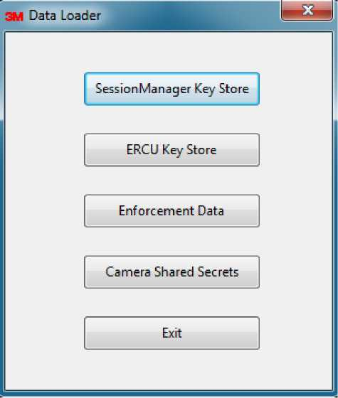
Figure 1 Data Loader main window
- Loading the SM Key Store CD
A valid SM key store (normally with serial number 1) CD must be loaded first before any
a
enforcement data CD or shared secret CD can be loaded into the system. ¹
The SM Key Store CD loading screen is shown in figure 2. Both a general SM key store CD and a SM recovery CD can be loaded from this point. You only need to select the key store file to be loaded from the file dialog as shown in figure 3 and provide the pass phrase to this key store file, and this data loader will automatically do all necessary update and
Changing the key store for the SM involves update of shared secret and session keys retained in SM/ERCU database. This needs access to both the previous key store and the new key store which it is desired to load. For security reasons, normally the SM key store must be changed in sequential serial order and using the pass phrase to access previous key store included in the CD. If your key store update doesn’t follow the natural order or the previous key store is corrupted in current machine, you will require a recovery SM key store CD with all necessary historic access keys from the system administrator of the Key Manager.
switch the key stores. Please note that enforcement data must be re-issued by the EM after a key store change. This CD may be generated automatically during the EM key store update operation.
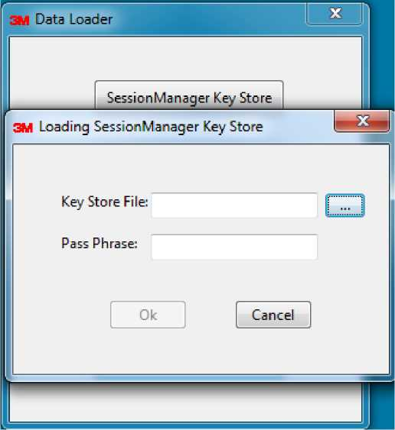
Figure 2 Loading SM key store dialog

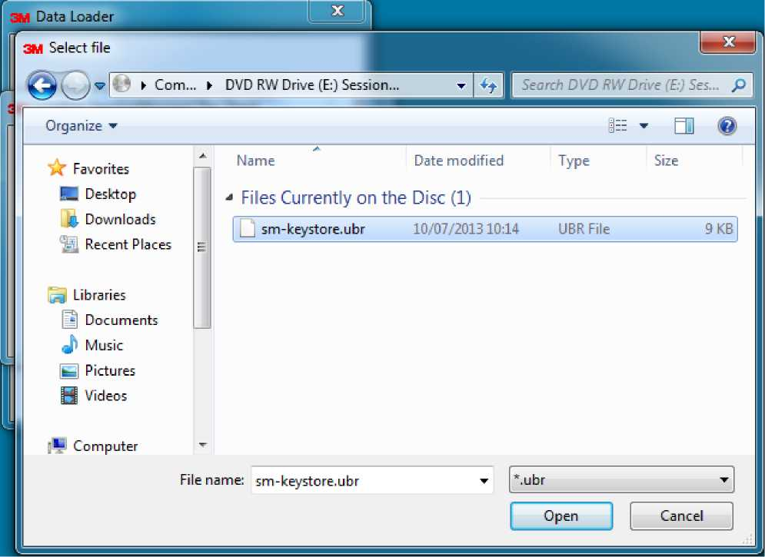
Figure 3 Selecting key store file in the CD from KM
- Loading the ERCU Key Store CD
This operation is only enabled on an ERCU machine, and its process is similar to SM key store loading operation as shown in figure 2 and 3. Select the ERCU key store from the CD loaded and provide appropriate passphrase to access it, and then the loader will automatically update the ERCU key store.
- Loading the Enforcement Data CD
The enforcement data CD comes from the EM, and includes information about the enforcement topology (cameras, nodes and links), link enforcement timetables and the enforced speed threshold. The dialogue for loading the Enforcement Data CD is shown in
figure 4, and the file is selected on the CD and the pass phrase to access the SM key store.
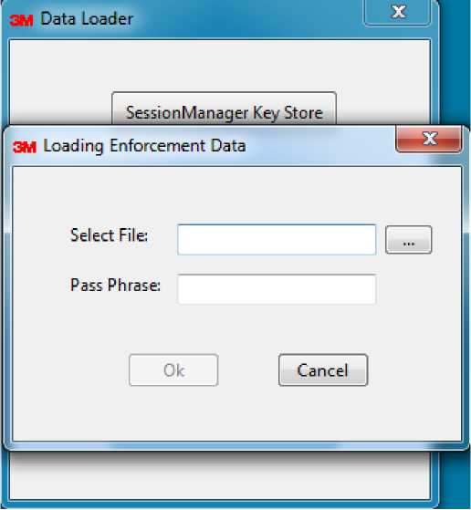
Figure 4 Loading enforcement data dialog Loading the Shared Secrets CD
4.
A shared secret CD is generated by KM and protected with a pass phrase. The loading process as shown in figure 5 requires two different pass phrases: the one to access the CD and the one to access current SM key store. Please note only shared secret for cameras already retained in SM/ERCU can be loaded, so you should load enforcement data CD containing corresponding cameras first.
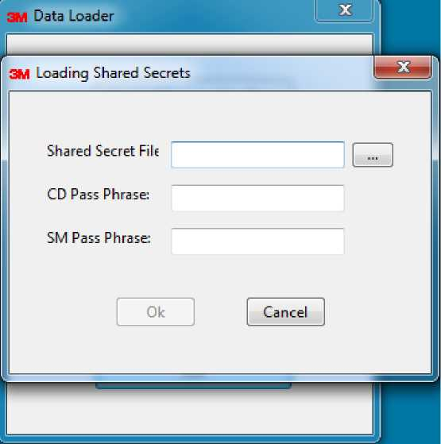
Figure 5 Loading camera shared secrets dialog
Appendix: Configurations
Some configuration can be set in file $DATA_LOADER/conf/dataloader.properties, which are shown as follows (you can ignore the first part if you are using stated default settings):
# run.as.windows.service indicate whether SM/ERCU are run as windows services, true by default run.as.windows.service = true
#sm.home and ercu.home indicates the host machine of SM/ERCU if running as windows services, #or the location where SM/ERCU are installed locally
sm.home = 127.0.0.1
ercu.home = 127.0.0.1

